

Activity map

User profiles

All

All

Select County

Select Organization

All

Select organization type

September 22, 2024

**USAID TARGETTING AND LAYERING PLATFORM**

Search Table

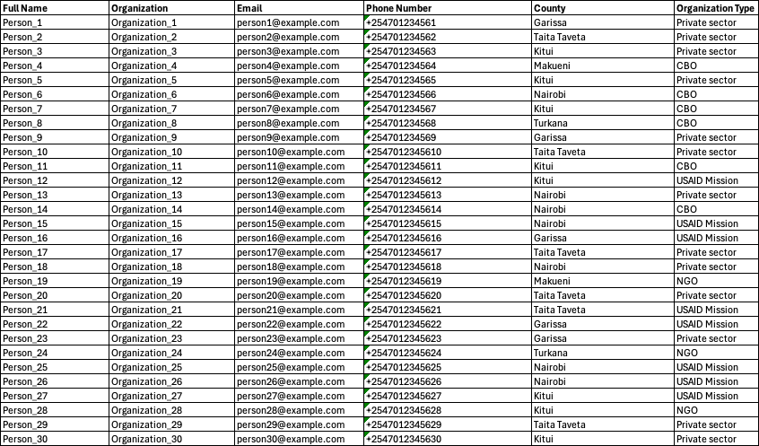

CSV download

MS Excel download

*This Knowledge Management Hub is facilitated by the Resilience Learning Activity, that is USAID funded. For the Partnership for Resilience and Economic Growth (PREG), RLA is the is the secretariat and the leading learning partner. The information provided on this Web site is not official U.S. Government information and does not represent the views or positions of the U.S. Agency for International Development (USAID) or the U.S. Government.*

© 2024 Resilience Learning Activity. Some Rights Reserved.